Name: Anuj Mahendra Mutha

Assignment 4 (Clound Computing)

Title: Installation and Configuration of virtualization using KVM

Step 1: Check if processor supports hardware virtualization

*tecomp@pict-OptiPlex-390:~$* ***grep -Eoc '(vmx|svm)' /proc/cpuinfo***

8

Step 2: Install Package

*root@pict-OptiPlex-390:/home/tecomp# apt install cpu-checker*

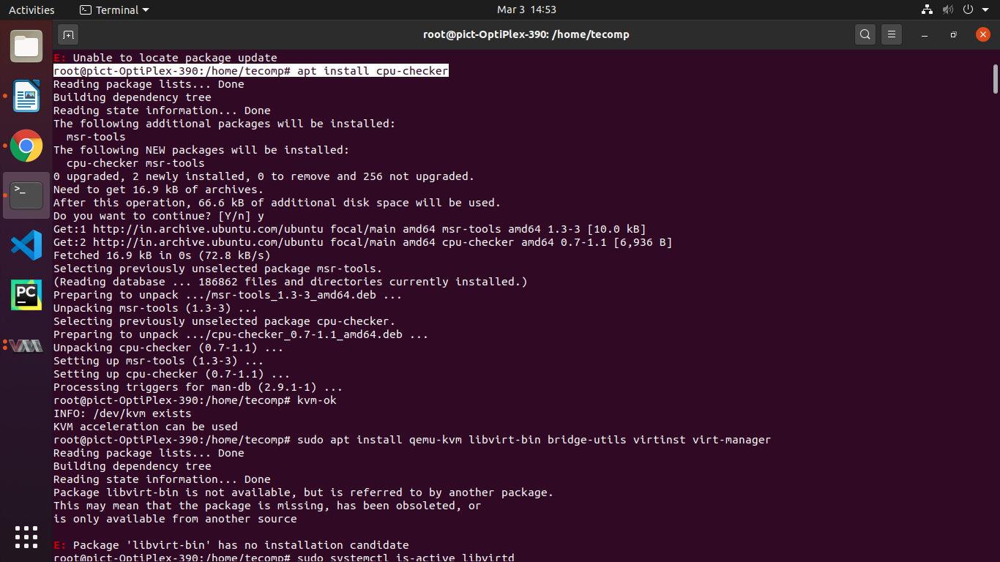

Step 3: The libvirt library is used to interface with different virtualization technologies. Check if your hardware supports the necessary virtualization extensions for KVM.

*root@pict-OptiPlex-390:/home/tecomp#* ***kvm-ok***

INFO: /dev/kvm exists

KVM acceleration can be used

Step 4: Install KVM and additional virtualization management packages.

*root@pict-OptiPlex-390:/home/tecomp#* ***apt install qemu-kvm libvirt-d aemon-system libvirt-clients bridge-utils virtinst virt-manager***

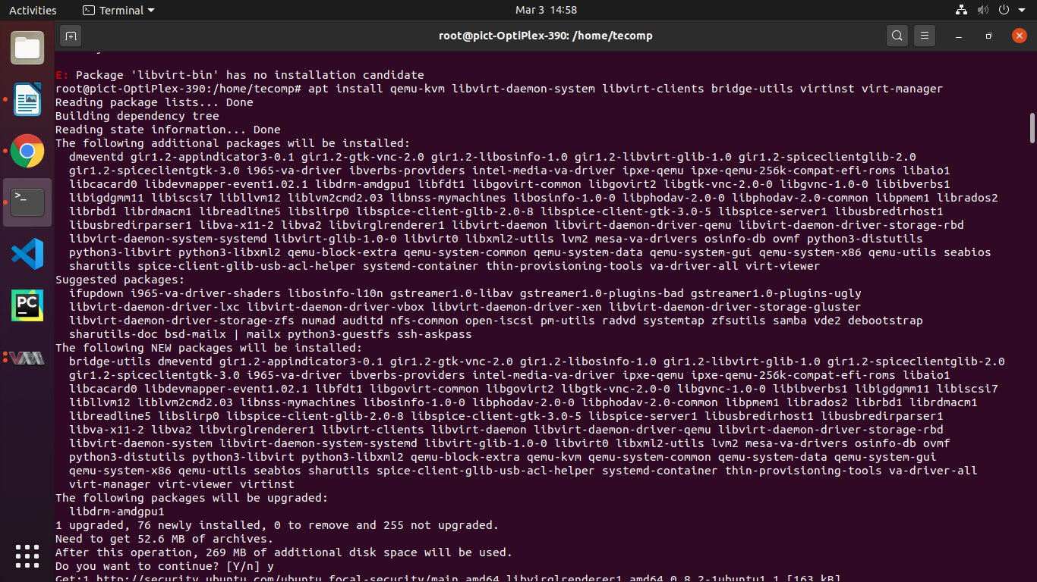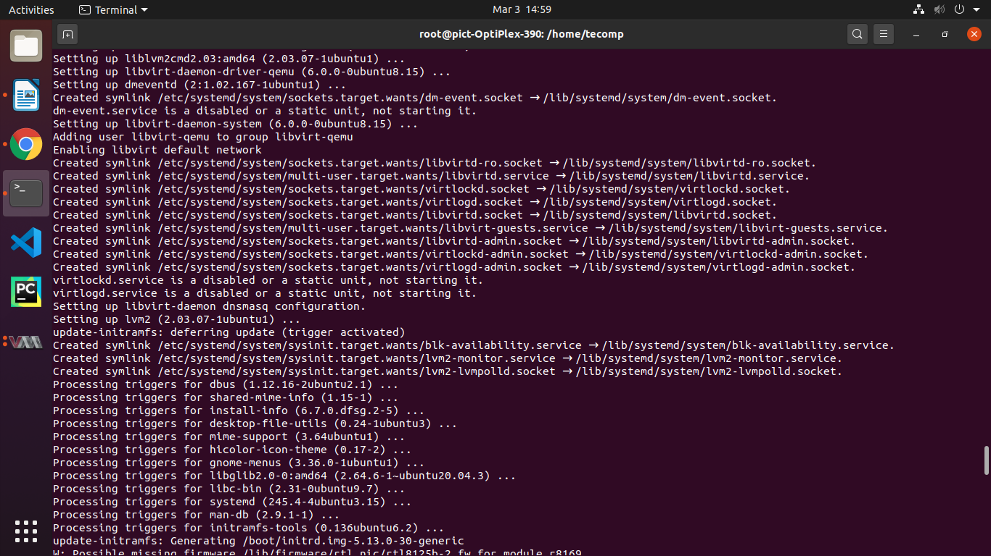

Step 5: Once package is installed, th libvirt daemon will run automatically. Verify it by:

*root@pict-OptiPlex-390:/home/tecomp#* ***sudo systemctl is-active libvirtd***

**active**

Step 6: Check the status of libvirt service.

*root@pict-OptiPlex-390:/home/tecomp#* ***service libvirtd status***

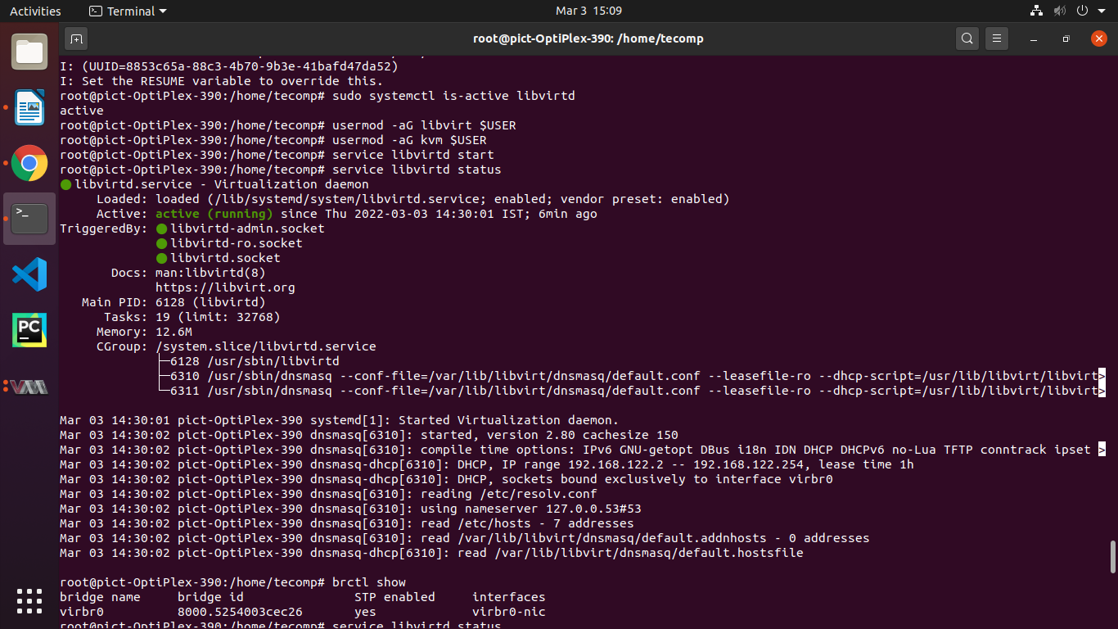

Step 7: Add our user to the “libvirt” and “kvm” groups, in order to be able to create and manage virtual machines.

*root@pict-OptiPlex-390:/home/tecomp# usermod -aG libvirt $USER*

*root@pict-OptiPlex-390:/home/tecomp# usermod -aG kvm $USER*

Step 8: As the KVM is installed and configured, we will be able to create VM either from the command line or using the virt-manager application.

Conclusion: Successfully installed and cnfigured KVM on Ubuntu system.